**Subnetting Exercise**

**Q.No 01: Given the address 192.168.2.0 – 255.255.255.0, borrow 3 bits and find the subnets with proper calculation?**

**Q.No 02: If you are working in an organization as junior Network Administrator, Network Administrator assigns you a Class C IP 192.16.10.22 255.255.255.252 for calculating its valid hosts range how you will perform this job?**

**Q.No 03: Find the subnet (Network ID) the host 192.168.246.189/29 belongs to with the calculation you have learned in class?**

**Q.No 04: Find out the Network and Broadcast ID from given IPs.**

**1.  12.5.6.111/26**

**2.  100.20.200.200/25**

**3.  216.0.0.189/30**

**4.  172.18.5.150/28**

**VLSM**

**Question No. 5**

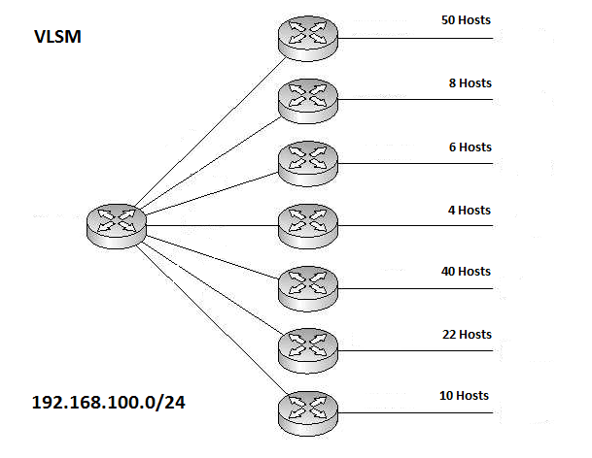

**Question 06**

